|  |  |  |
| --- | --- | --- |
|  | 0 | 36 |
|  | 1 | 33 |
|  | 2 | 34 |
|  | 3 | 38 |
|  | 4 | 47 |
|  | 5 | 43 |
|  | 6 | 49 |
|  | 7 | 34 |
|  | 8 | 49 |
|  | 9 | 40 |
|  | 10 | 33 |
|  | 11 | 33 |
|  | 12 | 32 |
|  | 13 | 42 |
|  | 14 | 39 |
|  | 15 | 49 |
|  | 16 | 31 |
|  | 17 | 35 |
|  | 18 | 38 |
|  | 19 | 33 |
|  | 20 | 34 |
|  | 21 | 35 |
|  | 22 | 32 |
|  | 23 | 36 |
|  | 24 | 37 |
|  | 25 | 39 |
|  | 26 | 26 |
|  | 27 | 38 |
|  | 28 | 29 |
|  | 29 | 35 |
|  | 30 | 17 |
|  | 31 | 30 |
|  | 32 | 31 |
|  | 33 | 36 |
|  | 34 | 23 |
|  | 35 | 47 |
|  | 36 | 44 |
|  | 37 | 23 |
|  | 38 | 22 |
|  | 39 | 41 |
|  | 40 | 25 |
|  | 41 | 35 |
|  | 42 | 25 |
|  | 43 | 22 |
|  | 44 | 28 |
|  | 45 | 26 |
|  | 46 | 35 |
|  | 47 | 46 |
|  | 48 | 32 |
|  | 49 | 22 |
|  | 50 | 22 |
|  | 51 | 33 |
|  | 52 | 19 |
|  | 53 | 30 |
|  | 54 | 38 |
|  | 55 | 28 |
|  | 56 | 23 |
|  | 57 | 29 |
|  | 58 | 39 |
|  | 59 | 42 |
|  | 60 | 36 |
|  | 61 | 35 |
|  | 62 | 26 |
|  | 63 | 35 |
|  | 64 | 35 |
|  | 65 | 35 |
|  | 66 | 19 |
|  | 67 | 26 |
|  | 68 | 32 |
|  | 69 | 24 |
|  | 70 | 32 |
|  | 71 | 22 |
|  | 72 | 38 |
|  | 73 | 28 |
|  | 74 | 21 |
|  | 75 | 24 |
|  | 76 | 46 |
|  | 77 | 38 |
|  | 78 | 35 |
|  | 79 | 33 |
|  | 80 | 31 |
|  | 81 | 43 |
|  | 82 | 20 |
|  | 83 | 33 |
|  | 84 | 26 |
|  | 85 | 34 |
|  | 86 | 35 |
|  | 87 | 29 |
|  | 88 | 20 |
|  | 89 | 35 |
|  | 90 | 33 |
|  | 91 | 37 |
|  | 92 | 28 |
|  | 93 | 36 |
|  | 94 | 35 |
|  | 95 | 39 |
|  | 96 | 36 |
|  | 97 | 34 |
|  | 98 | 36 |
|  | 99 | 64 |
|  | 100 | 29 |
|  |  |  |

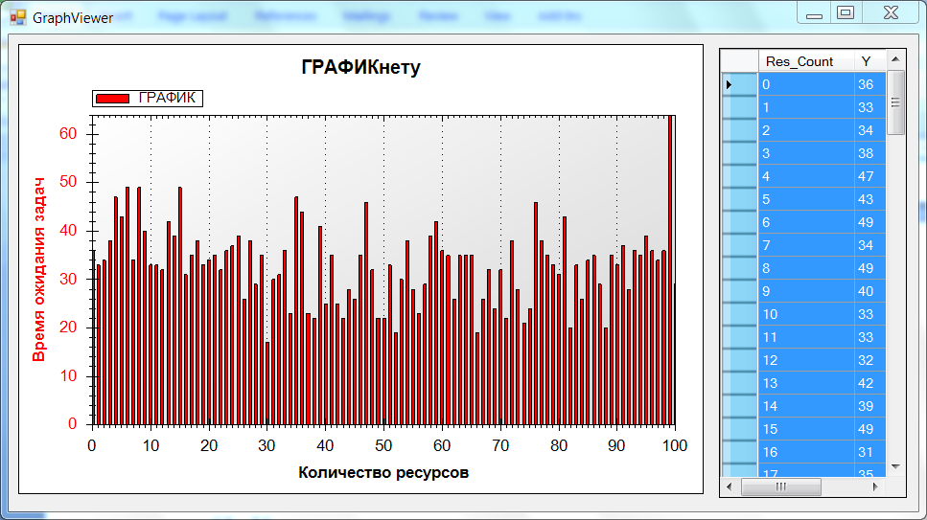

|  |  |  |
| --- | --- | --- |
|  | 0 | 29 |
|  | 1 | 27 |
|  | 2 | 30 |
|  | 3 | 27 |
|  | 4 | 27 |
|  | 5 | 28 |
|  | 6 | 25 |
|  | 7 | 30 |
|  | 8 | 29 |
|  | 9 | 31 |
|  | 10 | 31 |
|  | 11 | 32 |
|  | 12 | 33 |
|  | 13 | 30 |
|  | 14 | 32 |
|  | 15 | 32 |
|  | 16 | 31 |
|  | 17 | 34 |
|  | 18 | 31 |
|  | 19 | 30 |
|  | 20 | 30 |
|  | 21 | 33 |
|  | 22 | 32 |
|  | 23 | 34 |
|  | 24 | 33 |
|  | 25 | 29 |
|  | 26 | 33 |
|  | 27 | 35 |
|  | 28 | 34 |
|  | 29 | 34 |
|  | 30 | 34 |
|  | 31 | 33 |
|  | 32 | 33 |
|  | 33 | 34 |
|  | 34 | 32 |
|  | 35 | 34 |
|  | 36 | 33 |
|  | 37 | 34 |
|  | 38 | 36 |
|  | 39 | 33 |
|  | 40 | 33 |
|  | 41 | 36 |
|  | 42 | 34 |
|  | 43 | 36 |
|  | 44 | 34 |
|  | 45 | 35 |
|  | 46 | 37 |
|  | 47 | 35 |
|  | 48 | 35 |
|  | 49 | 35 |
|  | 50 | 35 |
|  | 51 | 35 |
|  | 52 | 35 |
|  | 53 | 35 |
|  | 54 | 35 |
|  | 55 | 36 |
|  | 56 | 34 |
|  | 57 | 35 |
|  | 58 | 36 |
|  | 59 | 36 |
|  | 60 | 36 |
|  | 61 | 34 |
|  | 62 | 36 |
|  | 63 | 37 |
|  | 64 | 36 |
|  | 65 | 37 |
|  | 66 | 36 |
|  | 67 | 35 |
|  | 68 | 37 |
|  | 69 | 34 |
|  | 70 | 36 |
|  | 71 | 35 |
|  | 72 | 36 |
|  | 73 | 37 |
|  | 74 | 36 |
|  | 75 | 37 |
|  | 76 | 36 |
|  | 77 | 35 |
|  | 78 | 37 |
|  | 79 | 36 |
|  | 80 | 38 |
|  | 81 | 37 |
|  | 82 | 36 |
|  | 83 | 36 |
|  | 84 | 37 |
|  | 85 | 36 |
|  | 86 | 36 |
|  | 87 | 37 |
|  | 88 | 35 |
|  | 89 | 37 |
|  | 90 | 36 |
|  | 91 | 37 |
|  | 92 | 36 |
|  | 93 | 37 |
|  | 94 | 36 |
|  | 95 | 36 |
|  | 96 | 36 |
|  | 97 | 35 |
|  | 98 | 36 |
|  | 99 | 38 |
|  | 100 | 36 |
|  |  |  |

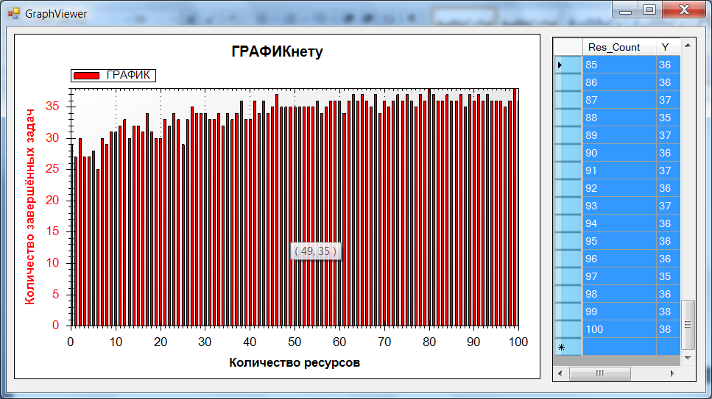

|  |  |  |
| --- | --- | --- |
|  | 0 | 27 |
|  | 1 | 28 |
|  | 2 | 24 |
|  | 3 | 32 |
|  | 4 | 33 |
|  | 5 | 29 |
|  | 6 | 35 |
|  | 7 | 27 |
|  | 8 | 25 |
|  | 9 | 25 |
|  | 10 | 20 |
|  | 11 | 22 |
|  | 12 | 20 |
|  | 13 | 23 |
|  | 14 | 20 |
|  | 15 | 23 |
|  | 16 | 20 |
|  | 17 | 16 |
|  | 18 | 23 |
|  | 19 | 21 |
|  | 20 | 22 |
|  | 21 | 16 |
|  | 22 | 17 |
|  | 23 | 16 |
|  | 24 | 19 |
|  | 25 | 23 |
|  | 26 | 18 |
|  | 27 | 14 |
|  | 28 | 16 |
|  | 29 | 14 |
|  | 30 | 12 |
|  | 31 | 17 |
|  | 32 | 16 |
|  | 33 | 17 |
|  | 34 | 16 |
|  | 35 | 16 |
|  | 36 | 16 |
|  | 37 | 15 |
|  | 38 | 12 |
|  | 39 | 15 |
|  | 40 | 14 |
|  | 41 | 14 |
|  | 42 | 12 |
|  | 43 | 12 |
|  | 44 | 12 |
|  | 45 | 13 |
|  | 46 | 12 |
|  | 47 | 13 |
|  | 48 | 12 |
|  | 49 | 12 |
|  | 50 | 10 |
|  | 51 | 10 |
|  | 52 | 10 |
|  | 53 | 11 |
|  | 54 | 13 |
|  | 55 | 10 |
|  | 56 | 10 |
|  | 57 | 10 |
|  | 58 | 12 |
|  | 59 | 9 |
|  | 60 | 10 |
|  | 61 | 13 |
|  | 62 | 11 |
|  | 63 | 10 |
|  | 64 | 12 |
|  | 65 | 10 |
|  | 66 | 9 |
|  | 67 | 10 |
|  | 68 | 10 |
|  | 69 | 9 |
|  | 70 | 10 |
|  | 71 | 10 |
|  | 72 | 10 |
|  | 73 | 10 |
|  | 74 | 9 |
|  | 75 | 9 |
|  | 76 | 11 |
|  | 77 | 11 |
|  | 78 | 10 |
|  | 79 | 9 |
|  | 80 | 10 |
|  | 81 | 9 |
|  | 82 | 9 |
|  | 83 | 9 |
|  | 84 | 9 |
|  | 85 | 9 |
|  | 86 | 10 |
|  | 87 | 10 |
|  | 88 | 9 |
|  | 89 | 9 |
|  | 90 | 10 |
|  | 91 | 9 |
|  | 92 | 9 |
|  | 93 | 9 |
|  | 94 | 9 |
|  | 95 | 9 |
|  | 96 | 9 |
|  | 97 | 9 |
|  | 98 | 9 |
|  | 99 | 9 |
|  | 100 | 9 |
|  |  |  |

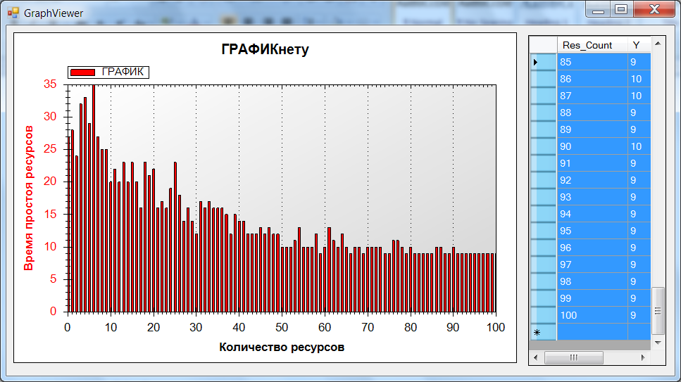

|  |  |  |
| --- | --- | --- |
|  | 0 | 38 |
|  | 1 | 37 |
|  | 2 | 35 |
|  | 3 | 33 |
|  | 4 | 43 |
|  | 5 | 39 |
|  | 6 | 39 |
|  | 7 | 37 |
|  | 8 | 39 |
|  | 9 | 27 |
|  | 10 | 35 |
|  | 11 | 43 |
|  | 12 | 36 |
|  | 13 | 34 |
|  | 14 | 36 |
|  | 15 | 31 |
|  | 16 | 36 |
|  | 17 | 33 |
|  | 18 | 31 |
|  | 19 | 31 |
|  | 20 | 37 |
|  | 21 | 30 |
|  | 22 | 29 |
|  | 23 | 26 |
|  | 24 | 31 |
|  | 25 | 32 |
|  | 26 | 27 |
|  | 27 | 28 |
|  | 28 | 33 |
|  | 29 | 30 |
|  | 30 | 36 |
|  | 31 | 28 |
|  | 32 | 29 |
|  | 33 | 26 |
|  | 34 | 43 |
|  | 35 | 36 |
|  | 36 | 25 |
|  | 37 | 37 |
|  | 38 | 31 |
|  | 39 | 31 |
|  | 40 | 26 |
|  | 41 | 33 |
|  | 42 | 29 |
|  | 43 | 28 |
|  | 44 | 32 |
|  | 45 | 24 |
|  | 46 | 29 |
|  | 47 | 32 |
|  | 48 | 29 |
|  | 49 | 38 |
|  | 50 | 35 |
|  | 51 | 35 |
|  | 52 | 33 |
|  | 53 | 39 |
|  | 54 | 31 |
|  | 55 | 36 |
|  | 56 | 30 |
|  | 57 | 35 |
|  | 58 | 30 |
|  | 59 | 32 |
|  | 60 | 36 |
|  | 61 | 33 |
|  | 62 | 29 |
|  | 63 | 27 |
|  | 64 | 29 |
|  | 65 | 28 |
|  | 66 | 25 |
|  | 67 | 33 |
|  | 68 | 33 |
|  | 69 | 35 |
|  | 70 | 34 |
|  | 71 | 33 |
|  | 72 | 25 |
|  | 73 | 29 |
|  | 74 | 30 |
|  | 75 | 30 |
|  | 76 | 32 |
|  | 77 | 34 |
|  | 78 | 26 |
|  | 79 | 34 |
|  | 80 | 32 |
|  | 81 | 33 |
|  | 82 | 31 |
|  | 83 | 29 |
|  | 84 | 32 |
|  | 85 | 26 |
|  | 86 | 30 |
|  | 87 | 31 |
|  | 88 | 27 |
|  | 89 | 35 |
|  | 90 | 34 |
|  | 91 | 33 |
|  | 92 | 29 |
|  | 93 | 31 |
|  | 94 | 37 |
|  | 95 | 29 |
|  | 96 | 32 |
|  | 97 | 34 |
|  | 98 | 35 |
|  | 99 | 36 |
|  | 100 | 43 |
|  |  |  |

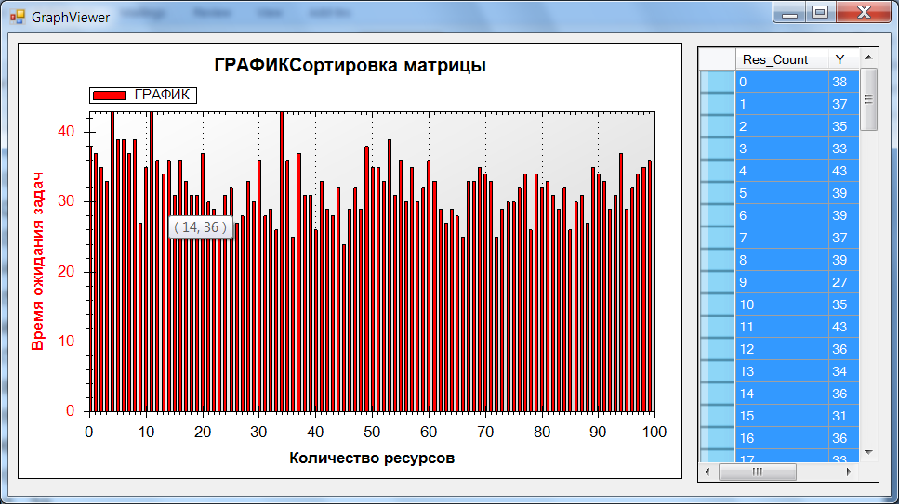

|  |  |  |
| --- | --- | --- |
|  | 0 | 25 |
|  | 1 | 21 |
|  | 2 | 28 |
|  | 3 | 24 |
|  | 4 | 21 |
|  | 5 | 23 |
|  | 6 | 24 |
|  | 7 | 25 |
|  | 8 | 26 |
|  | 9 | 28 |
|  | 10 | 27 |
|  | 11 | 28 |
|  | 12 | 26 |
|  | 13 | 28 |
|  | 14 | 26 |
|  | 15 | 28 |
|  | 16 | 29 |
|  | 17 | 27 |
|  | 18 | 30 |
|  | 19 | 30 |
|  | 20 | 31 |
|  | 21 | 28 |
|  | 22 | 30 |
|  | 23 | 29 |
|  | 24 | 29 |
|  | 25 | 30 |
|  | 26 | 29 |
|  | 27 | 30 |
|  | 28 | 29 |
|  | 29 | 29 |
|  | 30 | 29 |
|  | 31 | 31 |
|  | 32 | 29 |
|  | 33 | 31 |
|  | 34 | 31 |
|  | 35 | 29 |
|  | 36 | 30 |
|  | 37 | 30 |
|  | 38 | 30 |
|  | 39 | 30 |
|  | 40 | 30 |
|  | 41 | 29 |
|  | 42 | 30 |
|  | 43 | 29 |
|  | 44 | 30 |
|  | 45 | 29 |
|  | 46 | 31 |
|  | 47 | 29 |
|  | 48 | 30 |
|  | 49 | 30 |
|  | 50 | 30 |
|  | 51 | 30 |
|  | 52 | 30 |
|  | 53 | 30 |
|  | 54 | 30 |
|  | 55 | 30 |
|  | 56 | 31 |
|  | 57 | 28 |
|  | 58 | 30 |
|  | 59 | 29 |
|  | 60 | 30 |
|  | 61 | 30 |
|  | 62 | 30 |
|  | 63 | 30 |
|  | 64 | 29 |
|  | 65 | 30 |
|  | 66 | 32 |
|  | 67 | 30 |
|  | 68 | 30 |
|  | 69 | 30 |
|  | 70 | 30 |
|  | 71 | 30 |
|  | 72 | 29 |
|  | 73 | 30 |
|  | 74 | 30 |
|  | 75 | 30 |
|  | 76 | 30 |
|  | 77 | 30 |
|  | 78 | 30 |
|  | 79 | 31 |
|  | 80 | 30 |
|  | 81 | 30 |
|  | 82 | 30 |
|  | 83 | 30 |
|  | 84 | 30 |
|  | 85 | 31 |
|  | 86 | 30 |
|  | 87 | 30 |
|  | 88 | 30 |
|  | 89 | 30 |
|  | 90 | 30 |
|  | 91 | 30 |
|  | 92 | 30 |
|  | 93 | 30 |
|  | 94 | 30 |
|  | 95 | 30 |
|  | 96 | 30 |
|  | 97 | 30 |
|  | 98 | 30 |
|  | 99 | 30 |
|  | 100 | 30 |
|  |  |  |

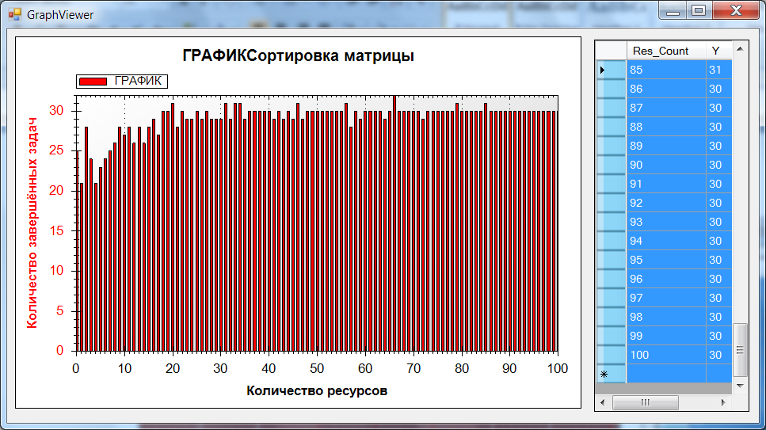

|  |  |  |
| --- | --- | --- |
|  | 0 | 33 |
|  | 1 | 41 |
|  | 2 | 28 |
|  | 3 | 41 |
|  | 4 | 39 |
|  | 5 | 38 |
|  | 6 | 39 |
|  | 7 | 34 |
|  | 8 | 32 |
|  | 9 | 27 |
|  | 10 | 31 |
|  | 11 | 30 |
|  | 12 | 28 |
|  | 13 | 26 |
|  | 14 | 28 |
|  | 15 | 23 |
|  | 16 | 23 |
|  | 17 | 25 |
|  | 18 | 24 |
|  | 19 | 24 |
|  | 20 | 25 |
|  | 21 | 24 |
|  | 22 | 24 |
|  | 23 | 24 |
|  | 24 | 23 |
|  | 25 | 22 |
|  | 26 | 23 |
|  | 27 | 20 |
|  | 28 | 23 |
|  | 29 | 23 |
|  | 30 | 23 |
|  | 31 | 21 |
|  | 32 | 22 |
|  | 33 | 21 |
|  | 34 | 24 |
|  | 35 | 23 |
|  | 36 | 21 |
|  | 37 | 22 |
|  | 38 | 22 |
|  | 39 | 20 |
|  | 40 | 20 |
|  | 41 | 22 |
|  | 42 | 20 |
|  | 43 | 22 |
|  | 44 | 21 |
|  | 45 | 22 |
|  | 46 | 23 |
|  | 47 | 23 |
|  | 48 | 22 |
|  | 49 | 21 |
|  | 50 | 22 |
|  | 51 | 21 |
|  | 52 | 20 |
|  | 53 | 20 |
|  | 54 | 21 |
|  | 55 | 22 |
|  | 56 | 21 |
|  | 57 | 22 |
|  | 58 | 23 |
|  | 59 | 21 |
|  | 60 | 22 |
|  | 61 | 22 |
|  | 62 | 22 |
|  | 63 | 20 |
|  | 64 | 22 |
|  | 65 | 20 |
|  | 66 | 22 |
|  | 67 | 21 |
|  | 68 | 22 |
|  | 69 | 20 |
|  | 70 | 22 |
|  | 71 | 20 |
|  | 72 | 21 |
|  | 73 | 22 |
|  | 74 | 21 |
|  | 75 | 21 |
|  | 76 | 22 |
|  | 77 | 22 |
|  | 78 | 22 |
|  | 79 | 22 |
|  | 80 | 21 |
|  | 81 | 22 |
|  | 82 | 21 |
|  | 83 | 21 |
|  | 84 | 21 |
|  | 85 | 21 |
|  | 86 | 21 |
|  | 87 | 22 |
|  | 88 | 21 |
|  | 89 | 22 |
|  | 90 | 21 |
|  | 91 | 22 |
|  | 92 | 20 |
|  | 93 | 22 |
|  | 94 | 22 |
|  | 95 | 21 |
|  | 96 | 21 |
|  | 97 | 22 |
|  | 98 | 20 |
|  | 99 | 20 |
|  | 100 | 22 |
|  |  |  |

